Q1)

The screenshot of the file ***“sample1.txt”,*** which is uploaded to the bucket is given below.

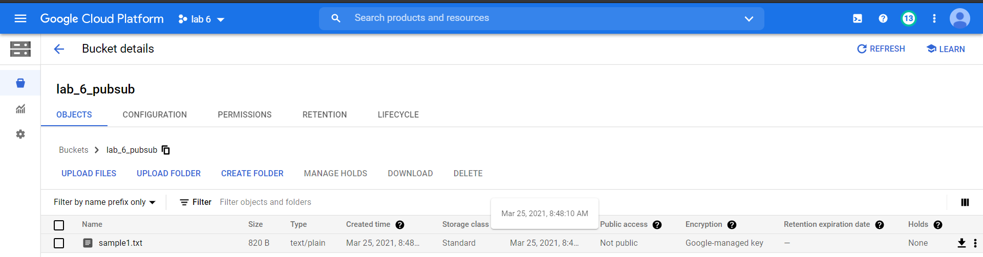 After uploading this file into the bucket, a google cloud function named ***“lab6_cloudfncn”*** gets triggered and it publishes the name of the uploaded file to google cloud pub/sub topic named ***“lab6_topic”.*** I have manually created a topic and subscription in the pub/sub.

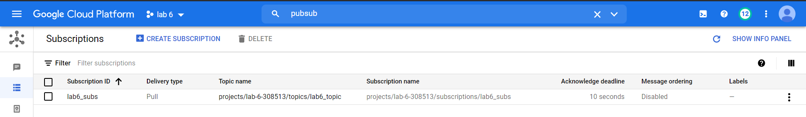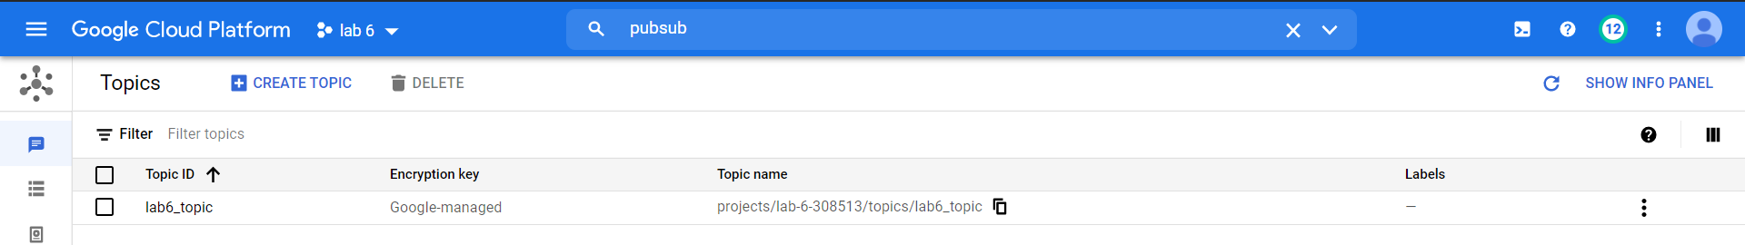Below are the screenshots of created topic and subscription.

The screenshot of the published message is attached below.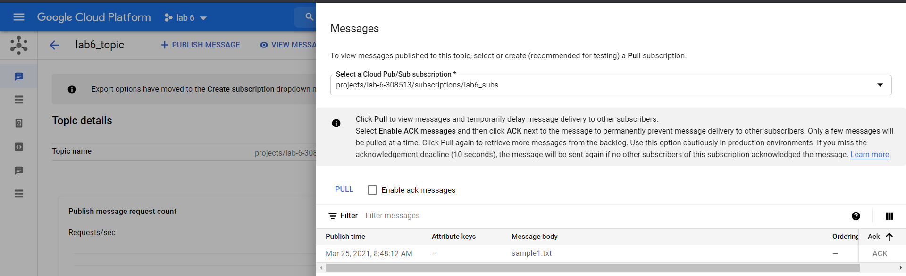

The below is the screenshot of the cloud function, including its logs.

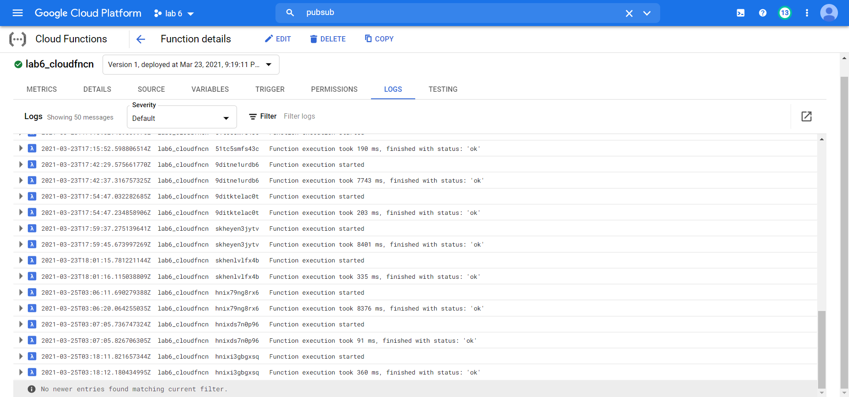

A python file named ***“lab6_LineCount.py”*** contains the code to subscribe to the topic through ***“lab6_subs”*** subscription and to print the number of lines in the file in real-time. In order to interrupt the code execution keyboard-interrupt must be given.

The below is the screenshot of the output of the code.

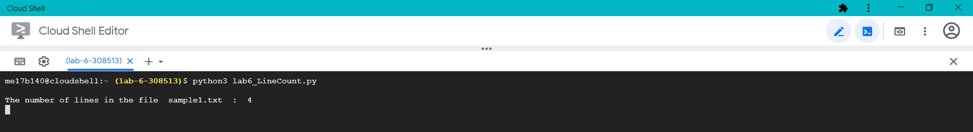

**Note: *The codes to the above process are attached with the submitted zip file.***

**Q2)**

**Pull subscription:** In pull subscription the subscriber application initiates requests to the Pub/Sub server to retrieve messages. The subscribing application explicitly calls the pull method, which requests messages for delivery. The Pub/Sub server responds with the message (or an error if the queue is empty), and an ack ID. The subscriber explicitly calls the acknowledge method, using the returned ack ID to acknowledge receipt.

**Push Subscription:** In push subscription the Pub/Sub initiates requests to subscriber application to deliver messages. The Pub/Sub server sends each message as an HTTPS request to the subscriber application at a pre-configured endpoint. The endpoint acknowledges the message by returning an HTTP success status code. A non-success response indicates that the message should be resent.

When to choose what:

* In case there is a need for load balancing I would go for push subscription because preconfigured end points are preferred for this case and are efficient.
* If I am using Pub/Sub to connect to my app on phone I will use pull subscription because I want to see messages whenever I am online or open the app.
* If I am continuously collecting IoT data for storing at a single end point I would use push subscription, because I am storing data.